EXPERIMENT-3
NAME : MITHULESH J ROLL NO : 240701313

1.COMMAND LINE INTERFACE:
PYTHON CODE:
# cli_delete.py
import os
import sys
if len(sys.argv) != 2:
print("Usage: python cli_delete.py <filename>")
sys.exit(1)
filename = sys.argv[1]
if os.path.exists(filename):
os.remove(filename)
print(f"File '{filename}' deleted successfully.")
else:
print("File not found.")

OUTPUT:
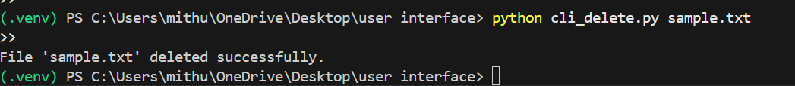

2.GRAPHICAL USER INTERFACE:
PYTHON CODE:
import os
import tkinter as tk
from tkinter import filedialog, messagebox
def delete_file():
file_path = filedialog.askopenfilename()
if file_path:
try:
os.remove(file_path)
messagebox.showinfo("Success", "File deleted successfully.")
except Exception as e:
messagebox.showerror("Error", str(e))
root = tk.Tk()
root.title("File Deleter")
root.geometry("300x150")
btn = tk.Button(root, text="Select File to Delete", command=delete_file)
btn.pack(expand=True)
root.mainloop()

OUTPUT:
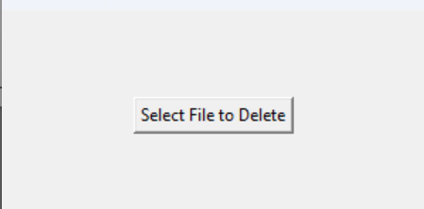
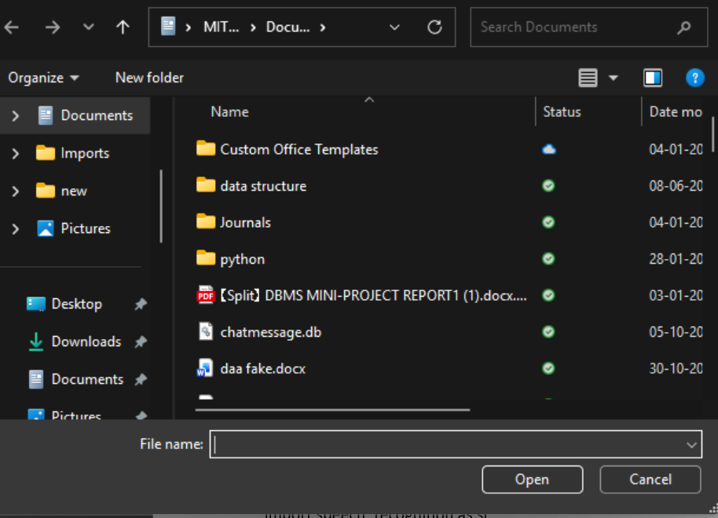

3.VOICE USER INTERFACE:
PYTHON CODE:
import os
import pyttsx3

engine = pyttsx3.init()

def speak(text):
engine.say(text)
engine.runAndWait()

speak("Voice interface activated")
speak("Please enter the file name to delete")

filename = input("Say (type) the file name to delete: ")

if os.path.isfile(filename):
os.remove(filename)
speak("File deleted successfully")
print("File deleted successfully")
else:
speak("File not found")
print("File not found")

output
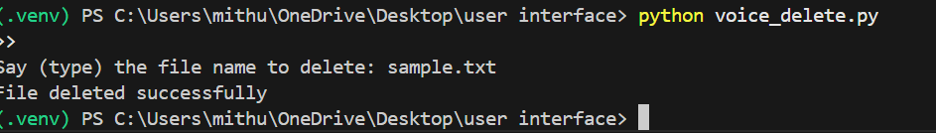

4.USER SATISFACTION COMPARISON:
PYTHON CODE:
import matplotlib.pyplot as plt
cli_scores = []
gui_scores = []
voice_scores = []
n = int(input("Enter number of users: "))
for i in range(n):
print(f"\nUser {i+1} Ratings (1 to 5)")
cli = int(input("CLI Satisfaction: "))
gui = int(input("GUI Satisfaction: "))
voice = int(input("Voice UI Satisfaction: "))
cli_scores.append(cli)
gui_scores.append(gui)
voice_scores.append(voice)
cli_avg = sum(cli_scores) / n
gui_avg = sum(gui_scores) / n
voice_avg = sum(voice_scores) / n
print("\nAverage Satisfaction Scores")
print("CLI:", cli_avg)
print("GUI:", gui_avg)
print("Voice UI:", voice_avg)
interfaces = ["CLI", "GUI", "Voice UI"]
scores = [cli_avg, gui_avg, voice_avg]
plt.bar(interfaces, scores)
plt.xlabel("User Interface Type")
plt.ylabel("Average Satisfaction Score")
plt.title("User Satisfaction Comparison")
plt.ylim(0, 5)
plt.show()

output

